Umar Mustapha
Umustapha874@gmail.com
Sales Performance Analysis

Introduction
The dataset captures Q1 sales transaction data for a grocery-focused retail firm operating across the United States, tracking customer, salesperson, region, city, state, shipper, ship name, payment type, product name, category, unit price, quantity, revenue, and shipping fee. Together these variables provide a complete view of how the business performs across regions, products, customers, and its sales team.
Story of the Data
The data tells the story of goods sold by a firm operating within the United States, capturing quantity purchased, shipping details, and the salesperson responsible for each sale. It connects revenue performance across regions, states, cities, product categories, and individual salespersons into a single operational picture, revealing exactly where the business is strong, where it is underperforming, and which specific people, products, and places are driving those results.
Industry Type
The dataset belongs to the Grocery Retail industry, with a specific focus on regional sales performance, salesperson productivity, and product category analysis.
Project Stakeholders
Key stakeholders include the firm's chief executives and marketing team, who rely on revenue generation as the primary measure of success and value across the business.
What Success Means to the Industry
Generating more revenue. Revenue is the most important point of focus for this business, and it is what leadership considers the core measure of value.

Variable Classification
Independent variables
These variables describe who and what is involved in each transaction. They include:
- Customer Name
- Salesperson
- Region
- City
- State
- Shipper Name
- Ship Name
- Payment Type
- Product Name
- Category
Dependent variables
These variables measure the financial outcome of each transaction. They include:
- Unit Price
- Quantity
- Revenue
- Shipping Fee
- Profit
Potential Analysis
- Regional performance by revenue generated.
- Performance analysis of each salesperson by revenue generated.
- Customer performance analysis by quantity purchased.
- Payment usage over time by quantity used per payment type.
- Best performing product of the year by quantity purchased.
- Product category performance by revenue and by quantity.
- Performance analysis for shipping destinations with reference to quantity and revenue.
- Salesperson performance by revenue and by region.
- Performance analysis of shipper name by revenue generated.
- Best performing ship name by quantity and revenue generated.
- Best performing city per state by quantity purchased and revenue generated.
- Product performance analysis by unit price and profit generated.
- Regional performance analysis by overall profit made from quantity purchased.
- Salesperson performance analysis with reference to city and revenue generated.
- Profit analysis by product category.
- Customer preferred shipper name analysis by shipping fee.
- Customer preferred payment type analysis by profit generated.
- Best performing ship name of the year by quantity delivered.
Analysis of Key Relationships
Sales by Representative
Observations
- Nancy Freehafer is the top-performing salesperson of the year, generating $104,252.34 in revenue.
- Anne Larsen follows in second place with $93,858.33.
- Andrew Cencini ranks third with $67,180.50.
- Mariya Sergienko, Laura Giussani, Michael Neipper, and Robert Zare occupy fourth through seventh place, generating $42,370.88, $41,091.41, $37,428.00, and $32,530.60 respectively.
- Jan Kotas is the lowest-performing salesperson, generating $16,350.50.
Insights
- Jan Kotas's low output represents a significant revenue gap relative to the top performer, and could be addressed either through performance management or targeted sales and marketing strategy training, alongside the fourth-through-seventh place performers.
- The top three salespersons, Nancy Freehafer, Anne Larsen, and Andrew Cencini, generated a meaningful majority of total sales revenue between them, making them strong candidates for retention incentives such as pay raises or bonuses.
Top 10 Customers
Observations
- Company D is the top-performing customer, generating $67,180.50 in revenue.
- Company H follows with $50,208.35, and Company BB with $43,710.00, rounding out the top three.
- Company F ranks fourth with $37,428.00, Company A fifth with $36,839.99, and Company I sixth with $32,530.60.
- Company J and Company Z occupy seventh and eighth place with $29,133.01 and $28,208.25 respectively.
- Company C sits in ninth place with $27,005.38, and Company K rounds out the top ten with $21,937.08.
Insights
- A loyalty or incentive program targeting these top ten customers could meaningfully encourage continued patronage, given how concentrated revenue is among this group.
- The top three and top five customers specifically stand out as candidates for stronger recognition, such as a company retreat, an all-expenses-paid trip, or a formal award, given their outsized contribution relative to the rest of the customer base.
Sales by Product Category
Observations
- Beverage is the top-performing product category, generating $110,577.11 in revenue.
- Sauces follow with $69,000.00, and Jams, Preserves with $51,541.00, rounding out the top three.
- Dairy products rank fourth with $33,129.60, and Dried Fruits and Nuts rank fifth with $27,999.50.
- Canned Meat is the lowest-performing category among the top five, generating $25,465.60.
- A small number of records (roughly $30 in total) appeared as blanks in the category field, later confirmed with the marketing team to be a shipping data entry error rather than a genuine gap.
Insights
- Beverage's dominant performance suggests it should remain a top stocking priority, since running low on this category carries the highest revenue risk of any product line.
- Canned Meat's comparatively weak performance relative to the other top-five categories warrants a targeted review of pricing or sales strategy to determine why it underperforms despite still ranking in the top tier.
Performance by State
Observations
- New York is the top-performing state, generating $67,180.50 in revenue.
- Oregon follows with $50,208.35, Florida with $50,145.33, Tennessee with $43,713.00, and Illinois with $41,095.01, rounding out the top five.
- Idaho, Colorado, and Nevada are the three lowest-performing states, generating $17,204.00, $16,350.50, and $15,365.50 respectively.
Insights
- The gap between New York's top performance and Nevada's lowest performance, more than $51,000, suggests the sales strategies working in New York could plausibly be adapted and tested in the lowest-performing states.
- Relocating or pairing top-performing salespersons with underperforming states and regions is a concrete, testable way to close this gap rather than treating regional variation as fixed.

Sales Trend Report
Observations
- December recorded the sharpest revenue spike of the year at $66,642.78.
- February was the weakest month, generating just $19,985.50.
- July through September showed a gentle but steady climb, from $27,318.54 to $34,949.97.
- July's $27,318.54 marked a steep downturn from June's peak of $55,601.61.
- The three strongest months of the year were June ($55,601.61), October ($53,033.59), and December ($66,642.78).
- June's sharp rise followed a steady build from April ($20,771.79) and May ($34,307.05).
- Despite the July pullback, the overall momentum for the year trended upward.
Insights
- February's consistently weak performance across the dataset (also the lowest month for several individual salespersons) suggests a sales audit specific to that month would help isolate whether the cause is seasonal, promotional, or structural.
- The sharp June-to-July drop, immediately following the year's first major peak, suggests whatever drove the June spike (a promotion, seasonal demand, or specific product push) did not carry forward, and understanding that cause could help sustain future peaks rather than losing momentum immediately after them.
Sales by Region
Observations
- The Northern region generated the highest revenue at $141,680.34, representing 32.56% of total revenue.
- The Eastern region follows with $108,275.51 (24.89%).
- The Southern region ranks third with $93,858.33 (21.5%).
- The Western region is the lowest performer at $91,251.98 (20.98%).
Insights
- With the North alone contributing nearly a third of total revenue, expansion into additional Northern cities is a reasonable next step for compounding an already-proven strength.
- The relatively narrow gap between East, South, and West (all clustered between roughly 21% and 25%) suggests that whatever the North is doing differently is worth studying closely, since the other three regions are performing at a fairly similar, comparatively lower level.
Individual Salesperson Deep Dive
Observations
- Andrew Cencini (Eastern region, New York) generated $67,180.50 for the year, peaking in June ($11,595.00) and December ($11,026.00), with April as his lowest month ($738.40). Jams, Preserves was his top category at $41,321.00. Company D was his only customer.
- Anne Larsen (Southern region, Florida and Tennessee) generated $93,858.33 across three customers, led by Company BB ($43,713.00). Sales peaked in December ($12,458.47) and dipped lowest in September ($4,629.11). Beverages was her top category at $29,278.08.
- Jan Kotas (Eastern region, Colorado) generated $16,350.50 from a single customer, Company CC. Sales peaked in June ($4,928.00) and December ($4,049.25), with no recorded sales in February and a low of $322.00 in July.
- Laura Giussani (Eastern region, Illinois) generated $41,095.01 across two customers, led by Company J ($29,133.01). Condiments was her top category at $15,048.00.
- Mariya Sergienko (Western region, California and Nevada) generated $42,370.88 across three customers, led by Company C ($27,005.38), with no recorded sales in August and a low of $1,320.08 in November.
- Michael Neipper (Eastern region, Wisconsin) generated $37,428.00 from a single customer, Company F, peaking in October ($6,738.50) and recording a $10 shipping fee error.
- Nancy Freehafer (Northern region, Oregon, Washington, Idaho) generated $104,252.34 across three customers, led by Company H ($50,208.35). Beverages was her top category at $47,695.99, and she also recorded a $10 shipping fee error.
- Robert Zare (Northern region, Utah) generated $32,530.60 from a single customer, Company I. Dairy Products was his top category at $18,444.00.
- The Eastern region as a whole, covering Andrew Cencini and Laura Giussani, generated a combined $108,275.51 from three customers, with Jams, Preserves as the leading category at $50,241.00.
Insights
- Five of the eight salespersons operate with only one or two customers each, a concentration risk. Losing a single account would materially impact several individual salespersons' entire book of business.
- Both of the two shipping fee errors identified ($10 each) occurred on the two highest-performing salespersons' accounts (Nancy Freehafer and Michael Neipper), suggesting a review of shipping fee calculation on high-volume accounts specifically, rather than a system-wide audit, may be the most efficient starting point.
Key Insights
- A Small Group Drives Most Revenue: Nancy Freehafer, Anne Larsen, and Andrew Cencini generated the clear majority of total sales revenue, while Jan Kotas trails at less than a sixth of the top performer's total.
- The North Is the Clear Regional Leader: At $141,680.34 and 32.56% of total revenue, the Northern region outperforms every other region, with East, South, and West clustering much closer together.
- Beverages Anchor the Product Line: At $110,577.11, Beverages generated more revenue than the next two categories combined, making it the single most important category to keep in stock.
- December and June Are the Business's Strongest Months: December ($66,642.78) and June ($55,601.61) mark the year's clearest peaks, while February ($19,985.50) is consistently the weakest month across the business and across individual salespersons alike.
- Customer Concentration Is a Real Risk: Several salespersons rely on just one or two customers for their entire revenue, meaning the loss of a single account could significantly disrupt individual performance.
- New York Leads, Nevada Trails: A gap of more than $51,000 separates the top state (New York) from the bottom state (Nevada), suggesting proven strategies from top states are worth testing in the lowest performers.
Data Visualizations and Charts
POWER BI ANALYSIS
Pre-Analysis Board
The pre-analysis board captures the project's independent and dependent variable split, industry context, stakeholders, and a set of 20 potential analysis questions and 18 potential insights identified before deeper relationship analysis was applied.
In-Analysis Board
The in-analysis board builds on the pre-analysis view by applying detailed observations and pre-insights across six core analyses: sales by representative, top 10 customers, sales by product category, performance by state, sales trend, and sales by region.
Dashboard
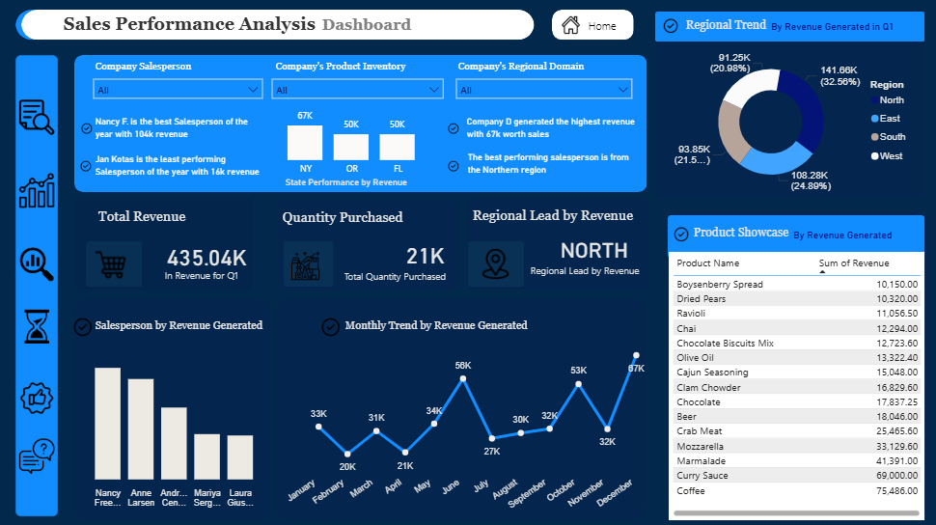
The final dashboard consolidates two KPI cards (Total Revenue, Quantity Purchased), a regional lead callout, a state performance breakdown, a regional trend donut chart, a monthly revenue trend line, a salesperson revenue bar chart, a scrollable product showcase table, and three interactive slicers (Salesperson, Product Name, Region).
KPI Summary
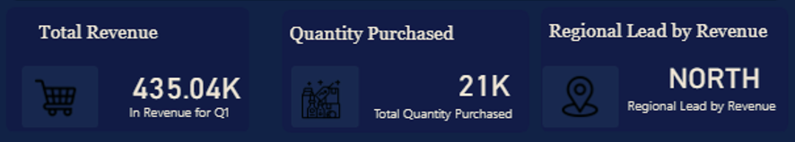
Total Revenue: 435.04K for Q1. Total Quantity Purchased: 21K. Regional Lead by Revenue: North.
Salesperson by Revenue Generated
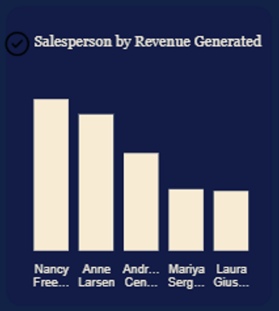
Column chart ranking salespersons by total revenue. Nancy Freehafer leads at $104,252.34, followed by Anne Larsen, Andrew Cencini, Mariya Sergienko, and Laura Giussani, with Jan Kotas recording the lowest revenue at $16,350.50.
Monthly Trend by Revenue Generated
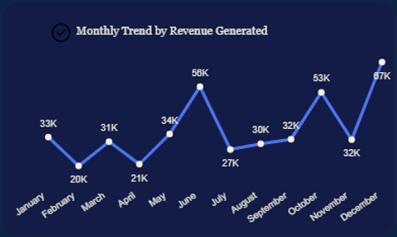
Line chart tracking monthly revenue across the year. December recorded the highest monthly revenue at $66,642.78, while February recorded the lowest at $19,985.50, with June and October as the other standout peaks.
Regional Trend (By Revenue Generated in Q1)
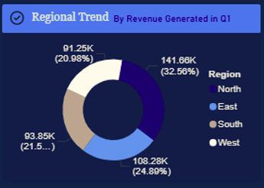
Donut chart showing revenue share by region. North leads at 32.56% ($141,680.34), followed by East at 24.89% ($108,275.51), South at 21.5% ($93,858.33), and West at 20.98% ($91,251.98).
State Performance by Revenue
Column chart comparing top states by revenue. New York leads at $67,180.50, followed by Oregon ($50,208.35) and Florida ($50,145.33), with Idaho, Colorado, and Nevada as the three lowest performers.
Product Showcase (By Revenue Generated)
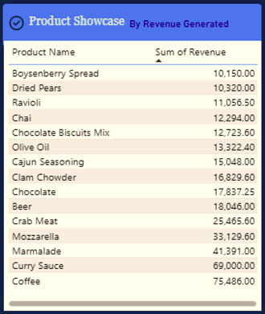
Sortable table listing individual products by revenue, ranging from Boysenberry Spread ($10,150.00) at the lower end up to Coffee ($75,486.00) as the single highest-revenue product listed.
Dashboard Summary
Power BI dashboard representing total revenue, quantity purchased, regional lead by revenue, salesperson revenue ranking, monthly revenue trend, regional revenue share, state-level revenue performance, and an individual product revenue table, with slicers for salesperson, product name, and region.
General Observations and Recommendations
General Observations
- Andrew Cencini, from the Eastern region (New York), generated $67,180.50 for the year, with Jams, preserves as his top category and Company D as his only customer, indicating single-customer dependency.
- Anne Larsen, from the Southern region (Florida and Tennessee), generated $93,858.33 across three customers, with Beverages as her leading category.
- Jan Kotas, from the Eastern region (Colorado), generated the lowest revenue of the year at $16,350.50, relying on a single customer, with no recorded sales in February.
- Laura Giussani, from the Eastern region (Illinois), generated $41,095.01 with Condiments as her top-selling category.
- Mariya Sergienko, from the Western region (California and Nevada), generated $42,370.88 with no recorded sales in August.
- Michael Neipper, from the Eastern region (Wisconsin), generated $37,428.00 from a single customer and recorded a $10 shipping fee error.
- Nancy Freehafer, from the Northern region, is the top-performing salesperson of the year at $104,252.34, also recording a $10 shipping fee error.
- Robert Zare, from the Northern region (Utah), generated $32,530.60 from a single customer, with Dairy Products as his top category.
- The Eastern region, combining Andrew Cencini and Laura Giussani, generated $108,275.51 total, with Jams, Preserves as the leading category.
- Beverage sales were strongest in the Northern region ($57,873.99), suggesting strong regional demand for that category specifically.
- Jams, Preserves sell more strongly in the Eastern region and less in the South, while Beverages show the reverse pattern, stronger in the South and weaker in the East.
General Recommendations
- Strongly recommend applying the methodology used in June and December, the year's strongest months, to other months in order to improve overall revenue.
- Recommend that salespersons with only one customer, including Andrew Cencini, Jan Kotas, Michael Neipper, and Robert Zare, actively cross-sell other products to their existing regional or state contacts to diversify their customer base and reduce single-account dependency.
- Recommend Jan Kotas for probation or performance improvement support, potentially pairing him with Nancy Freehafer in the North to learn her sales methodology, alongside additional training in marketing and sales strategy.
- Recommend a regional price reduction event for low-performing products across all regions to attract more customers and drive incremental purchases of other items.
- Recommend that Northern region beverage offerings be expanded within the proven 0 to 1,000 price range that already drives the highest transaction volume in that region.
- Recommend Nancy Freehafer, the top-performing salesperson of the year, for a formal award and pay raise to encourage continued high performance.
- Recommend Company D, the top customer of the year, for a discount voucher to encourage continued patronage.
- Recommend rebalancing product shipments regionally: increase Jams, Preserves shipped to the East (where it outperforms) and reduce shipments South, while doing the reverse for Beverages, which perform better in the South than in the East.
Conclusion
This analysis shows a business with a genuinely strong Q1, $435.04K in total revenue and 21K units purchased, but one where that strength is heavily concentrated rather than evenly distributed. Revenue leans hard on a small group of top performers: Nancy Freehafer, Anne Larsen, and Andrew Cencini among salespersons, Company D and the rest of the top ten customers, Beverages as a product category, and the Northern region overall.
Regional performance clearly favors the North, at nearly a third of total revenue, while East, South, and West cluster at a comparatively similar, lower level. Salesperson performance shows an even sharper divide, more than a sixfold gap between the top and bottom performer, and a customer concentration risk sitting underneath several individual salespersons' books of business.
Seasonality reinforced itself throughout the data: December and June stood out consistently as peak months, not just at the company level but within individual salesperson performance too, while February was the weakest month across nearly every cut of the data. That level of consistency makes February a clear, specific target for investigation rather than a coincidence.
The clearest opportunity in this dataset is not a single fix, but a coordinated one: replicate what is working in the North and in December/June elsewhere in the business, address the customer concentration risk sitting under several salespersons' accounts, and treat Jan Kotas's and Nevada's underperformance as solvable problems with a proven internal model (Nancy Freehafer, New York) already sitting right inside the same dataset.
Limitations of the Study
Despite the valuable insights generated, this study has several limitations that should be considered when interpreting the results:
- Single Quarter Scope: The dashboard's KPI totals reflect Q1 specifically, while the monthly trend and salesperson totals appear to reflect a fuller annual view, creating some ambiguity about the exact time period each total represents.
- Profit Not Fully Analyzed: Profit is listed as a dependent variable and a "potential column to be appended," but the current analysis is built almost entirely around revenue, meaning true profitability by salesperson, region, or product remains unexamined.
- Small Data Entry Errors Present: Two shipping fee errors ($10 each) and a small blank-category data issue (about $30) were identified, both explained but not corrected within the current dataset.
- Customer Concentration Not Independently Verified: While several salespersons appear to rely on one or two customers, the dataset does not clarify whether this reflects assigned account structure or a genuine business risk, that distinction would change the appropriate recommendation.
Suggestions for Future Work
To build on the findings of this study, future work could explore the following areas:
- Profit-Based Analysis: Append and analyze the Profit column directly, rather than relying on revenue alone, to determine which salespersons, regions, and products are genuinely most valuable to the business.
- February Root-Cause Investigation: Conduct a dedicated sales audit specifically for February, given its consistent underperformance across nearly every salesperson and region.
- Customer Concentration Risk Assessment: Clarify whether single-customer salesperson accounts reflect deliberate account assignment or a genuine retention risk, and build a diversification plan accordingly.
- Cross-Regional Strategy Transfer Study: Formally document what the Northern region and top salespersons like Nancy Freehafer are doing differently, and pilot those specific practices in the Western region and with lower-performing salespersons.
- Payment Type and Shipper Analysis: Extend the analysis into the untouched questions from the pre-analysis board, payment type usage, shipper performance, and ship name preference, to round out the full operational picture.

